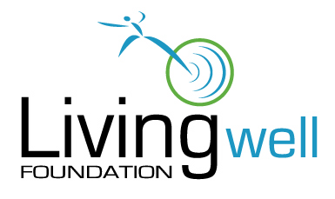
Disclosure Form

Please complete the table below and include all information as requested.

Question | Yes (type yes) | No  (type no) | If “yes”, provide explanation.
1. Is any director, officer, or employee of the applicant organization also a director, officer, or employee of the Living Well Foundation?
2. Is any director or officer of the application organization also an agent, consultant, or contractor of the Living Well Foundation, or the owner of a greater than 10% beneficial interest in any entity that is an agent, consultant, or contractor of the Living Well Foundation?
3. Does any director, officer, or employee of the Living Well Foundation, or the spouse, parent, sibling, or child, or any director, officer, or employee of the Living Well Foundation, have an actual or potential compensation arrangement with the applicant organization, or hold or expect to hold a position as an officer, director, trustee, or other similar authority with the applicant organization?
4. Does any director or officer of the applicant organization have any known relationship with any director, officer, or employee of the Foundation?
5. Will any director, officer, or employee of the applicant organization, or any immediate family member of any director, officer, or employee of the applicant organization, be a party to, or the owner of, a greater than 10% beneficial interest in any entity that is a party to any contract with the application organization that will be funded in whole or in part with any of the funds sought from the Living Well Foundation? (This includes any subcontractors or vendors.)
7. Is there any other potential conflict or information regarding those who may be involved with the funding that you should disclose?
6. Does your organization have an open competitive bidding or negotiation process? |  |  | (No explanation required.)

